1. Run nslookup to obtain the IP address of a Web server in Asia. What is the IP address of that server?

-> Ran the function nslookup on www.slc.edu.in

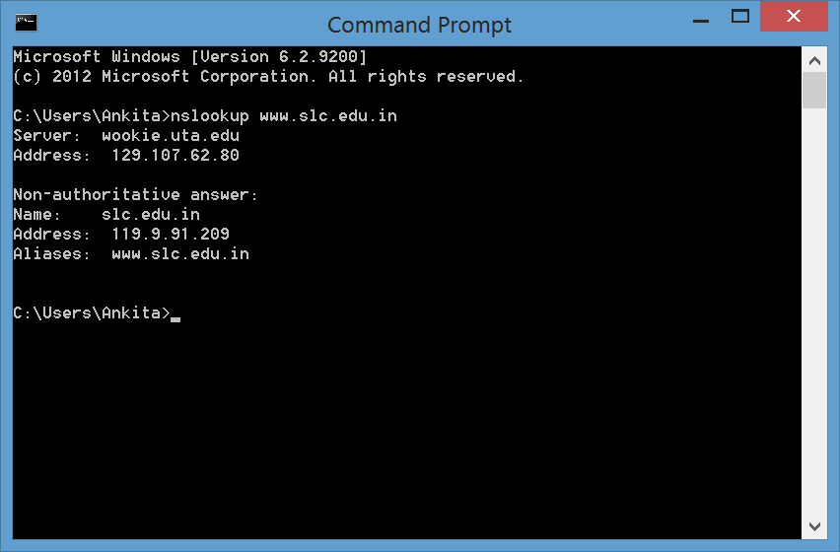

2. Run nslookup to determine the authoritative DNS servers for a university in Europe.

-> Performed the nslookup function for Cambridge University (www.cam.ac.uk)

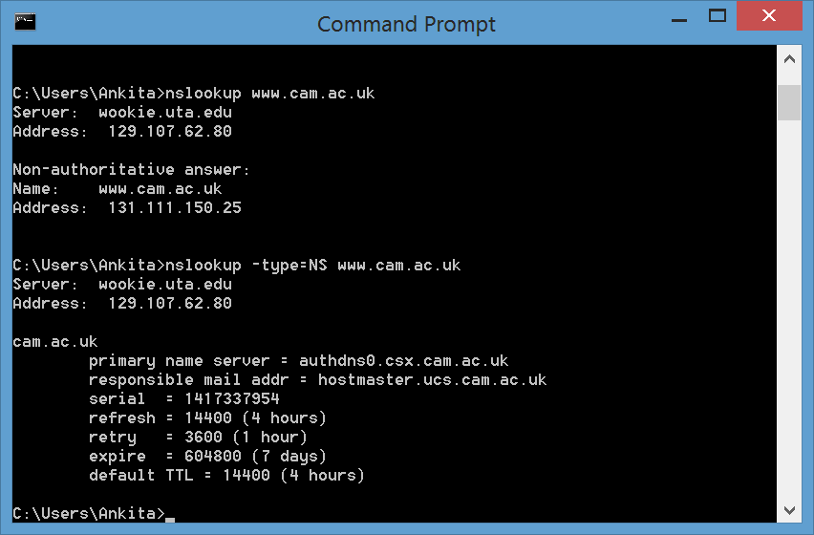

3. Run nslookup so that one of the DNS servers obtained in Question 2 is queried for the mail servers for Yahoo! mail. What is its IP address? -> The IP address is 98.138.79.21

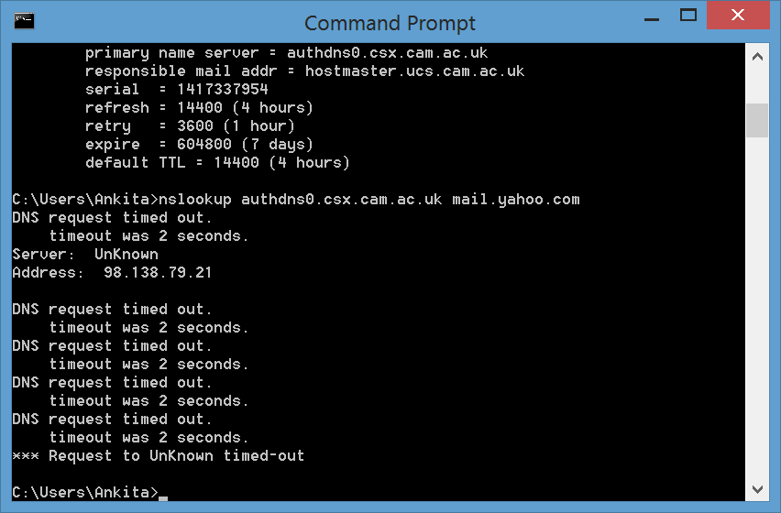

4. Locate the DNS query and response messages. Are then sent over UDP or TCP?

DNS Query

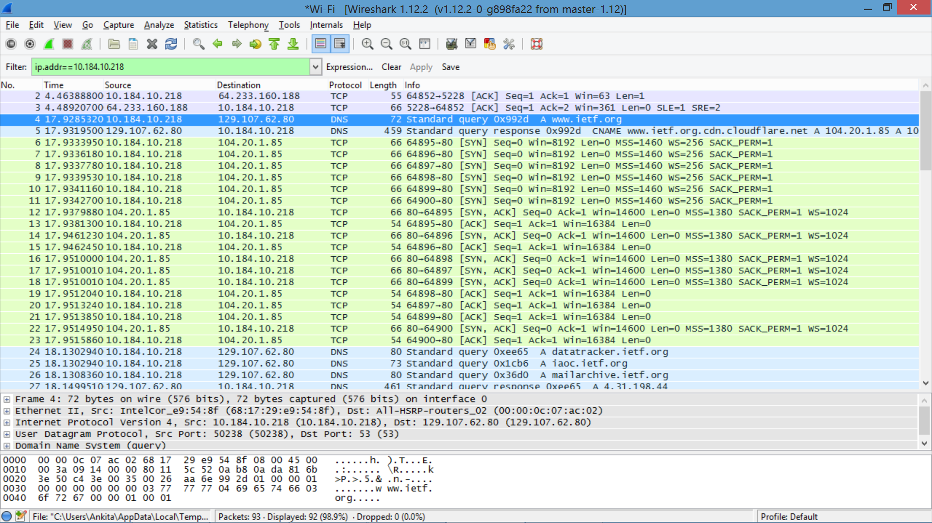

DNS Response

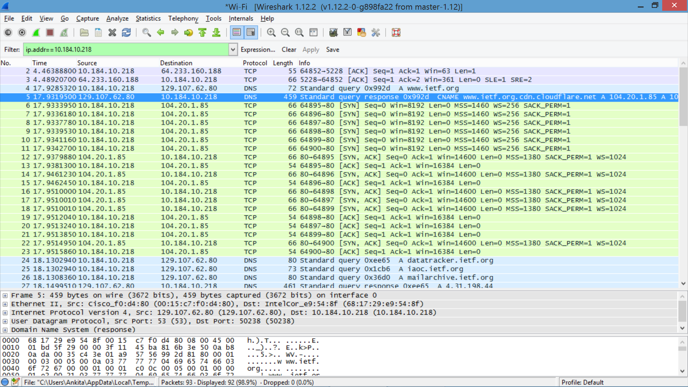

-> Both of the query and the response were sent by UDP.

5. What is the destination port for the DNS query message? What is the source port of DNS response message?

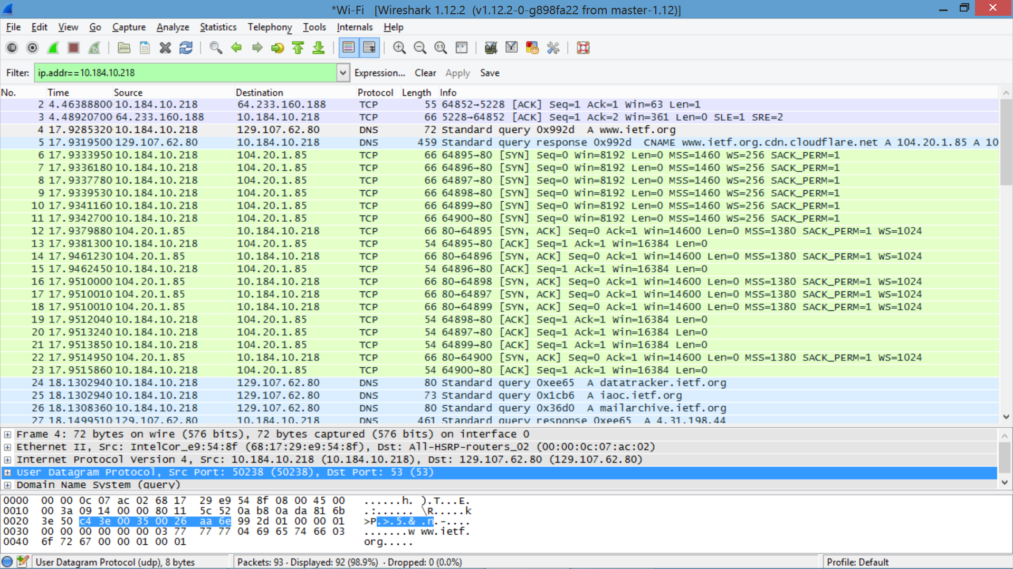

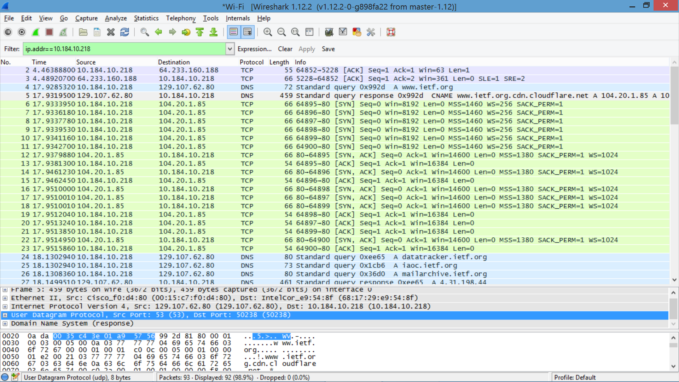

-> The destination port for the DNS query is 53 and the source port of the DNS response is 53.

6. To what IP address is the DNS query message sent? Use ipconfig to determine the IP address of your local DNS server. Are these two IP addresses the same?

-> The DNS query is sent to 10.184.10.218

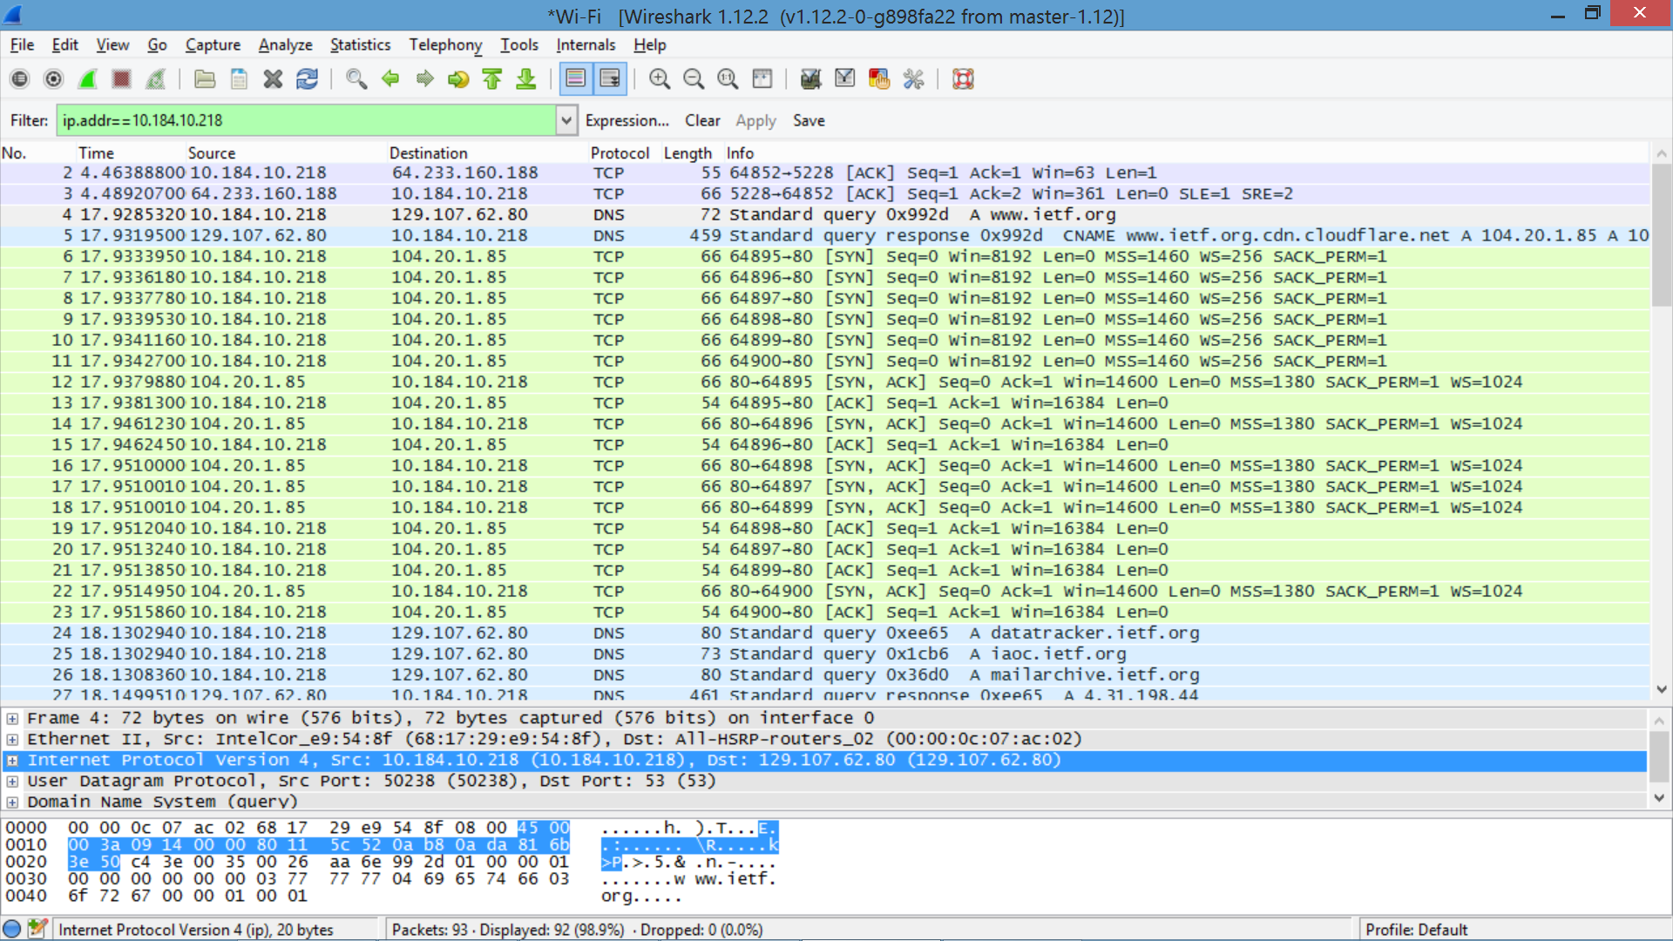

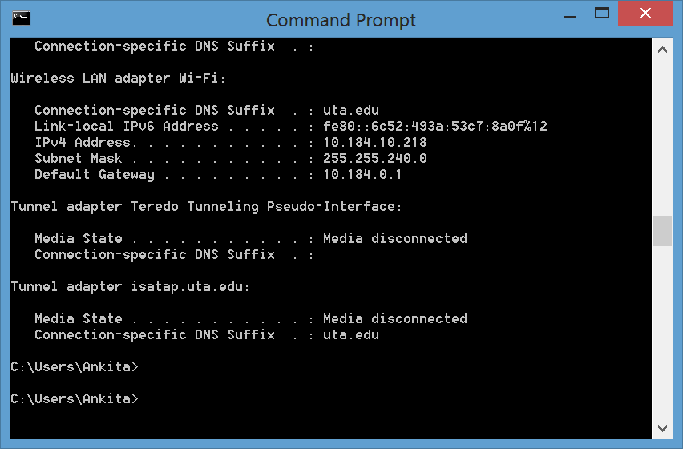

7. Examine the DNS query message. What “Type” of DNS query is it? Does the query message contain any “answers”?

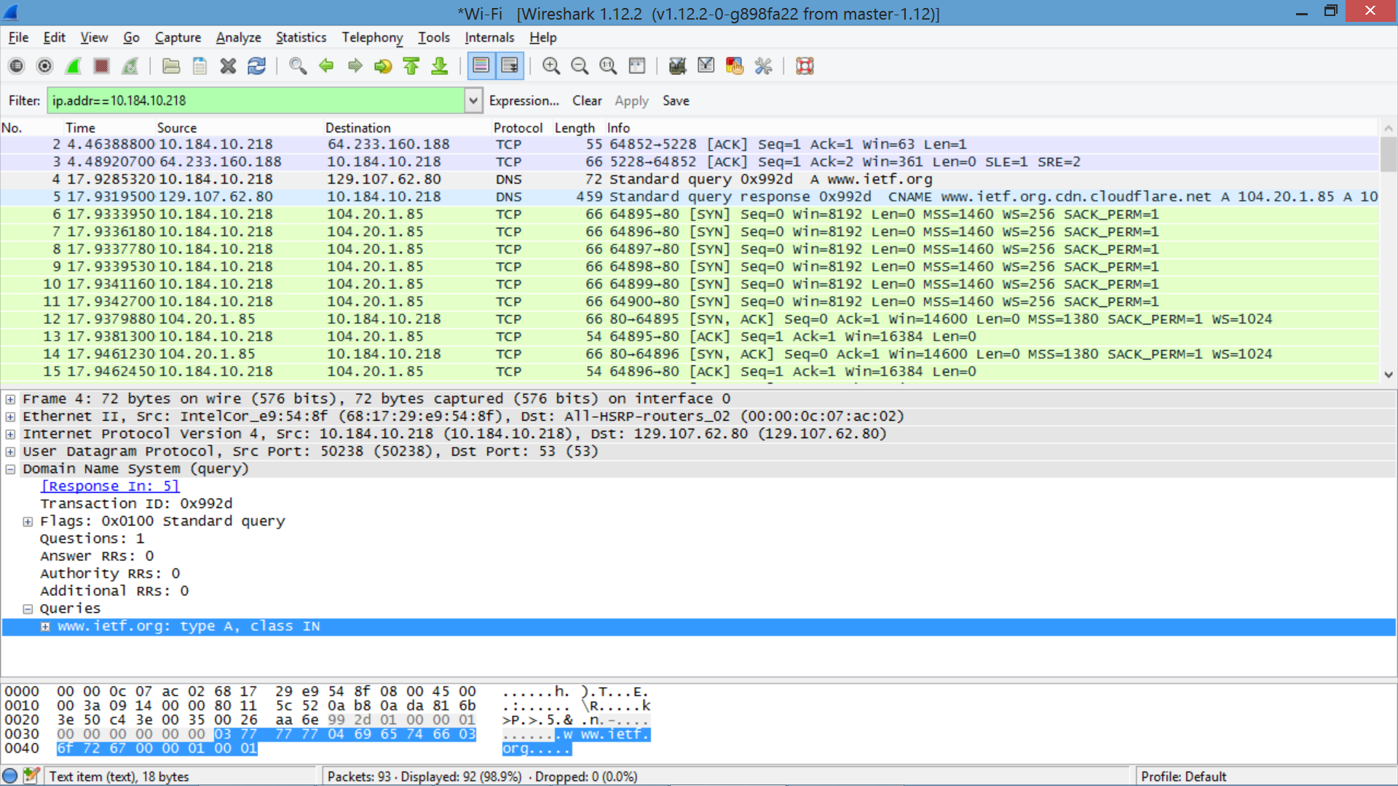

-> It’s a type A Standard Query and it doesn’t contain any answers.

8. Examine the DNS response message. How many “answers” are provided? What do each of these answers contain?

-> There are 3 answers containing information about the name of the host, the type of address, class, the TTL, the data length and the IP address.

|  |
| --- |
| Answers  www.ietf.org: type CNAME, class IN, cname www.ietf.org.cdn.cloudflare.net  Name: www.ietf.org  Type: CNAME (Canonical NAME for an alias) (5)  Class: IN (0x0001)  Time to live: 482  Data length: 33  CNAME: www.ietf.org.cdn.cloudflare.net  www.ietf.org.cdn.cloudflare.net: type A, class IN, addr 104.20.1.85  Name: www.ietf.org.cdn.cloudflare.net  Type: A (Host Address) (1)  Class: IN (0x0001)  Time to live: 248  Data length: 4  Address: 104.20.1.85 (104.20.1.85)  www.ietf.org.cdn.cloudflare.net: type A, class IN, addr 104.20.0.85  Name: www.ietf.org.cdn.cloudflare.net  Type: A (Host Address) (1)  Class: IN (0x0001)  Time to live: 248  Data length: 4  Address: 104.20.0.85 (104.20.0.85) |

9. Consider the subsequent TCP SYN packet sent by your host. Does the destination IP address of the SYN packet correspond to any of the IP addresses provided in the DNS response message?

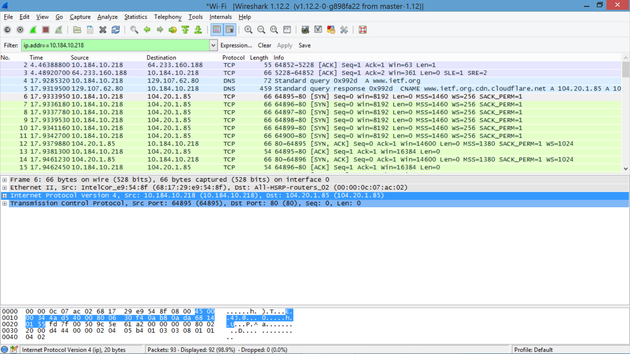

-> The first SYN packet was sent to 104.20.1.85 which corresponds to the IP address provided in the DNS response message.

10. This web page contains images. Before retrieving each image, does your host issue new DNS queries?

-> No, the host does not issue any new DNS queries.

**Part 3b**

11. What is the destination port for the DNS query message? What is the source port of DNS response message?

-> The destination port for the query message is 53.

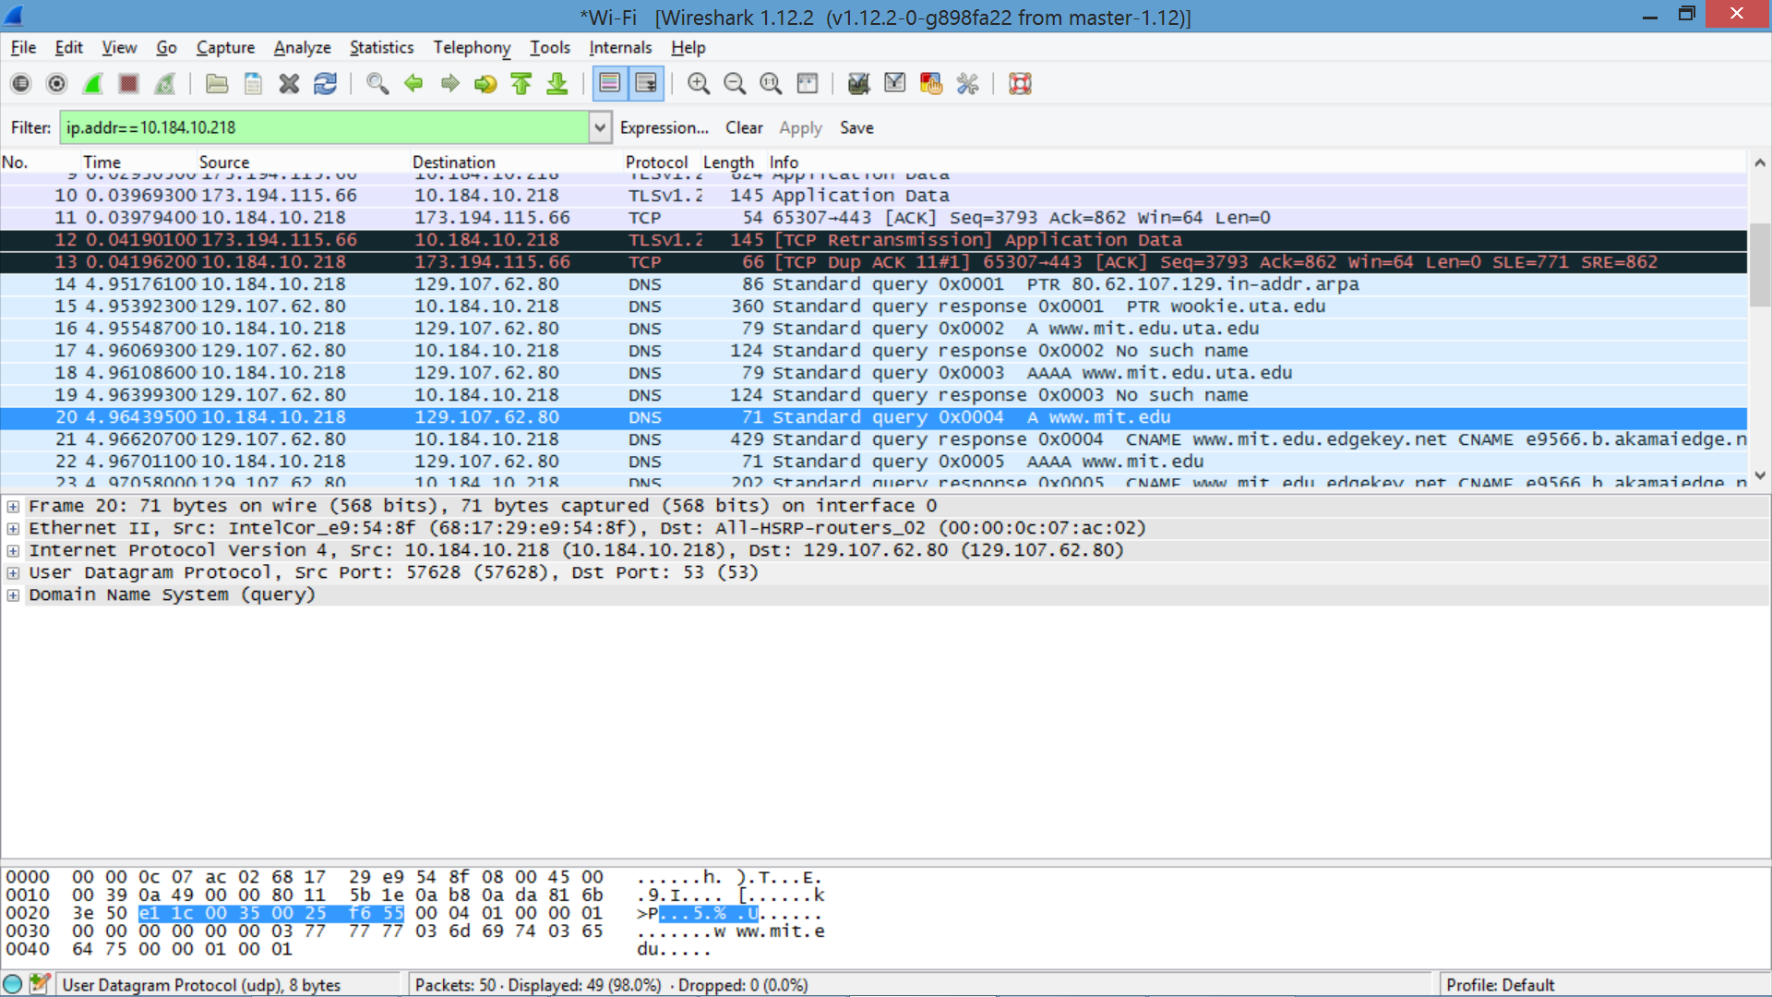

-> The source port of the response message is also 53.

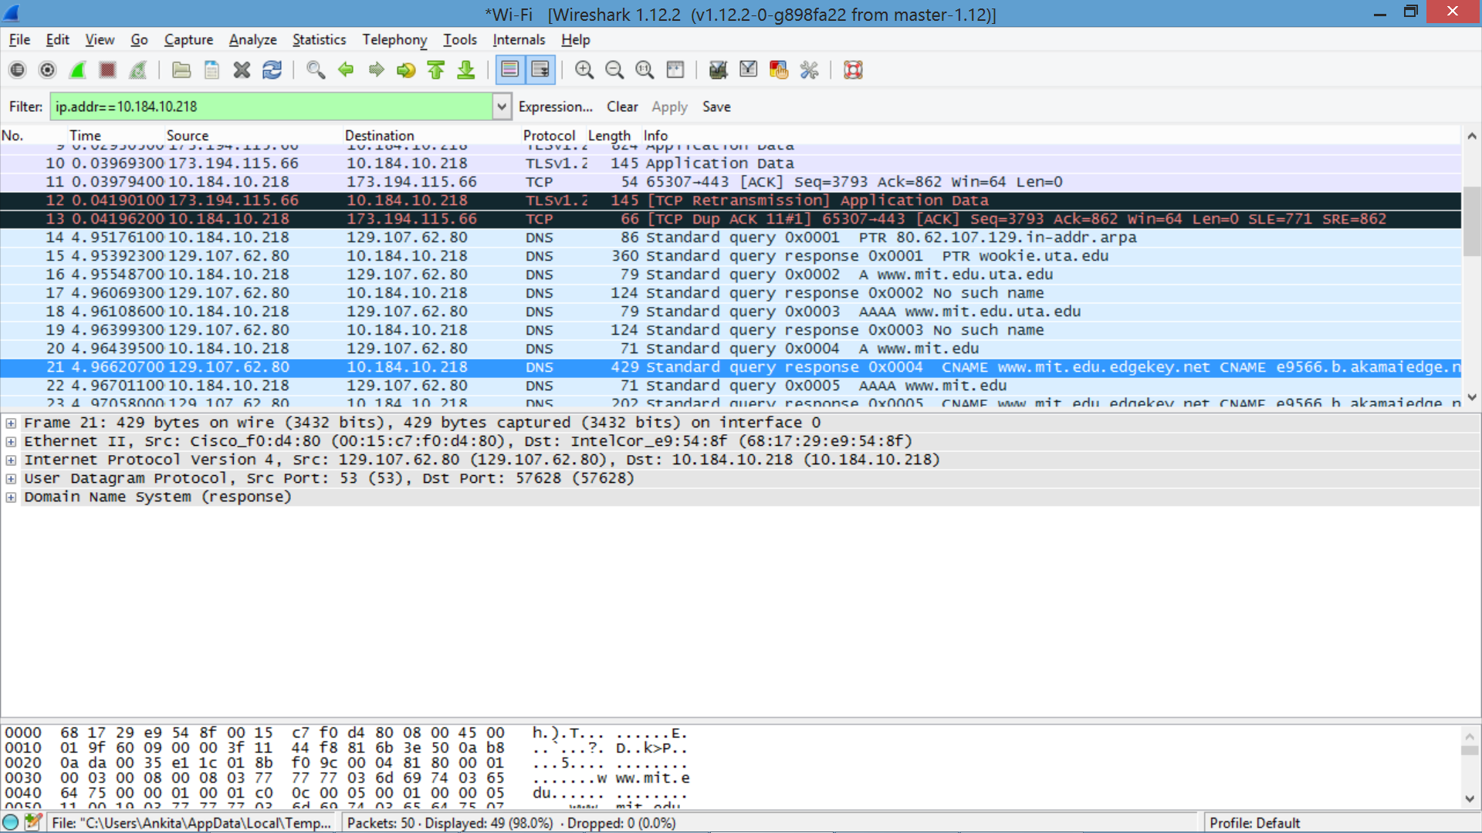

12. To what IP address is the DNS query message sent? Is this the IP address of your default local DNS server?

-> It’s sent to 10.184.10.218 which is the default local DNS server.



13. Examine the DNS query message. What “Type” of DNS query is it? Does the query message contain any “answers”?

-> The query is of type A and it doesn’t contain any answers.

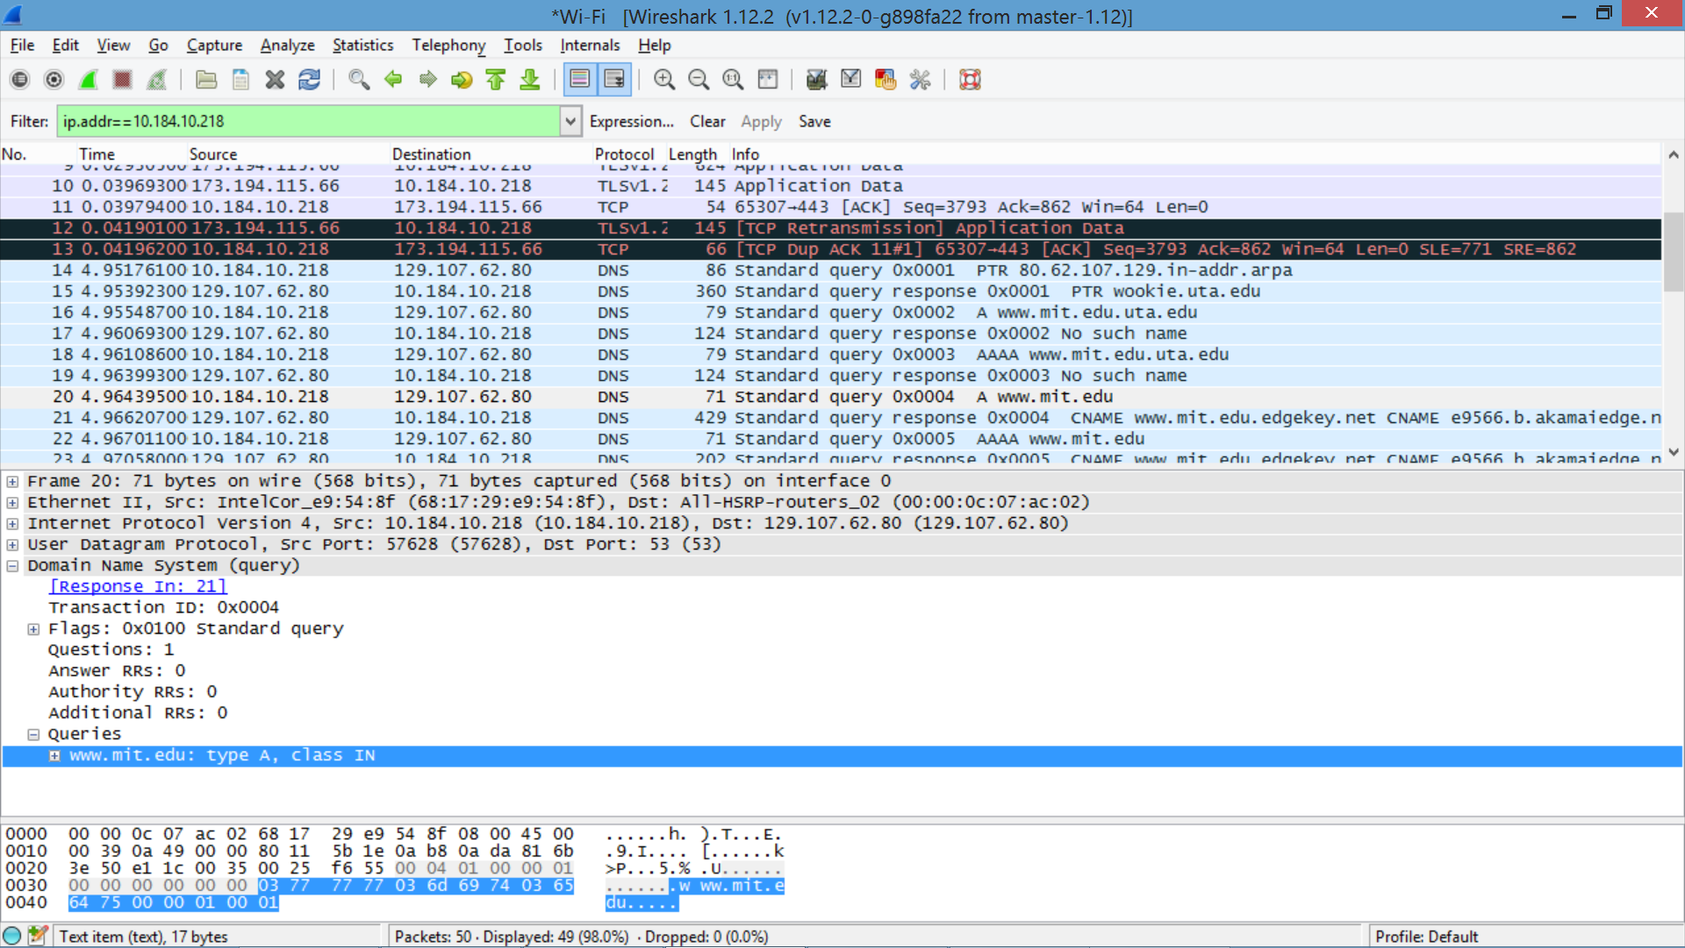

14. Examine the DNS response message. How many “answers” are provided? What do each of these answers contain?

-> There are 3 answers containing information about the name of the host, the type of address, class, the TTL, the data length and the IP address.

|  |
| --- |
| Answers  www.mit.edu: type CNAME, class IN, cname www.mit.edu.edgekey.net  Name: www.mit.edu  Type: CNAME (Canonical NAME for an alias) (5)  Class: IN (0x0001)  Time to live: 1297  Data length: 25  CNAME: www.mit.edu.edgekey.net  www.mit.edu.edgekey.net: type CNAME, class IN, cname e9566.b.akamaiedge.net  Name: www.mit.edu.edgekey.net  Type: CNAME (Canonical NAME for an alias) (5)  Class: IN (0x0001)  Time to live: 57  Data length: 21  CNAME: e9566.b.akamaiedge.net  e9566.b.akamaiedge.net: type A, class IN, addr 23.207.46.93  Name: e9566.b.akamaiedge.net  Type: A (Host Address) (1)  Class: IN (0x0001)  Time to live: 17  Data length: 4  Address: 23.207.46.93 (23.207.46.93) |

15. Provide a screenshot. 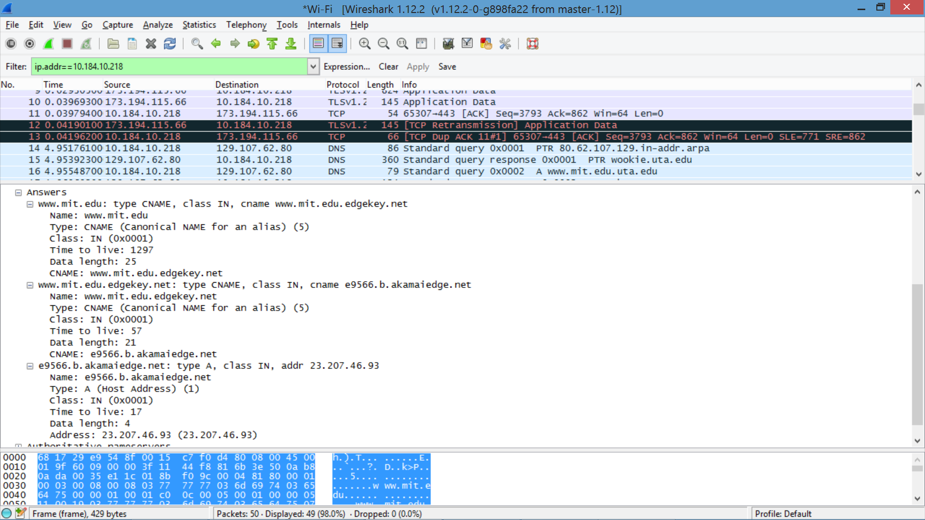

**Part 3c**

16. To what IP address is the DNS query message sent? Is this the IP address of your default local DNS server?

-> It’s sent to 10.184.10.218 which is the default local DNS server.

17. Examine the DNS query message. What “Type” of DNS query is it? Does the query message contain any “answers”?

-> It’s a type NS DNS query that doesn’t contain any answers.

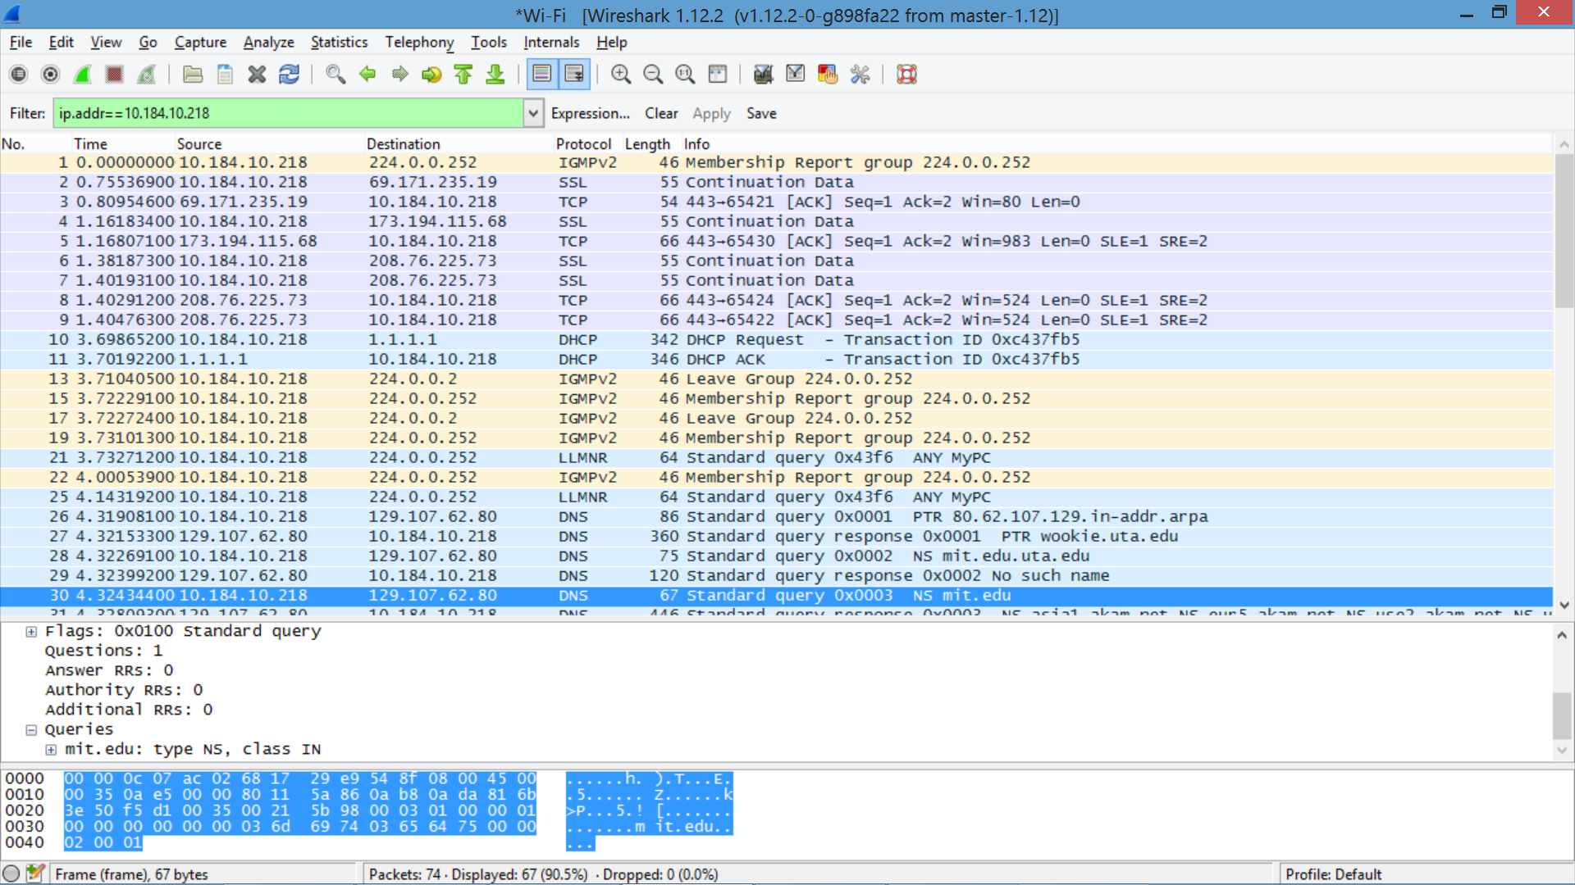

18. Examine the DNS response message. What MIT nameservers does the response message provide? Does this response message also provide the IP addresses of the MIT nameservers?

|  |
| --- |
| Answers  mit.edu: type NS, class IN, ns asia1.akam.net  mit.edu: type NS, class IN, ns eur5.akam.net  mit.edu: type NS, class IN, ns use2.akam.net  mit.edu: type NS, class IN, ns usw2.akam.net  mit.edu: type NS, class IN, ns use5.akam.net  mit.edu: type NS, class IN, ns ns1-173.akam.net  mit.edu: type NS, class IN, ns ns1-37.akam.net  mit.edu: type NS, class IN, ns asia2.akam.net |

Yes we can find the IP address of the MIT nameservers by opening the Additional Records.

19. Provide a screenshot.

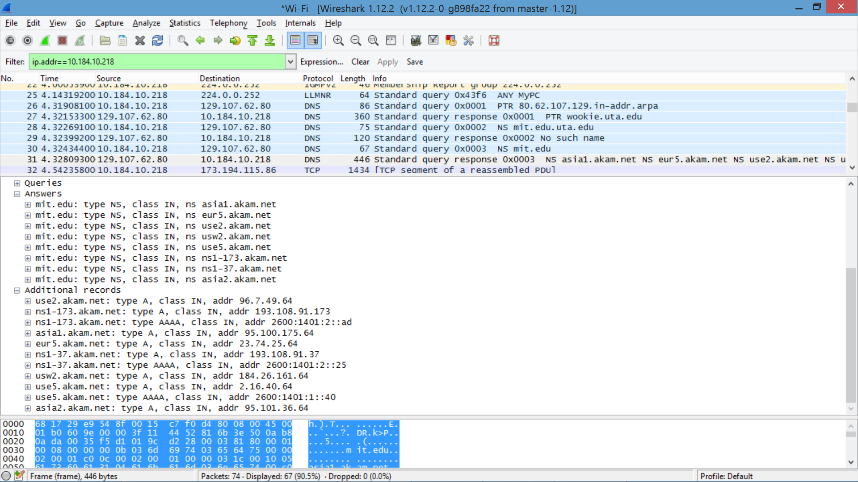

**Part 3d**

20. To what IP address is the DNS query message sent? Is this the IP address of your default local DNS server? If not, what does the IP address correspond to?

-> The query is sent to 18.72.0.3 which corresponds to bitsy.mit.edu.

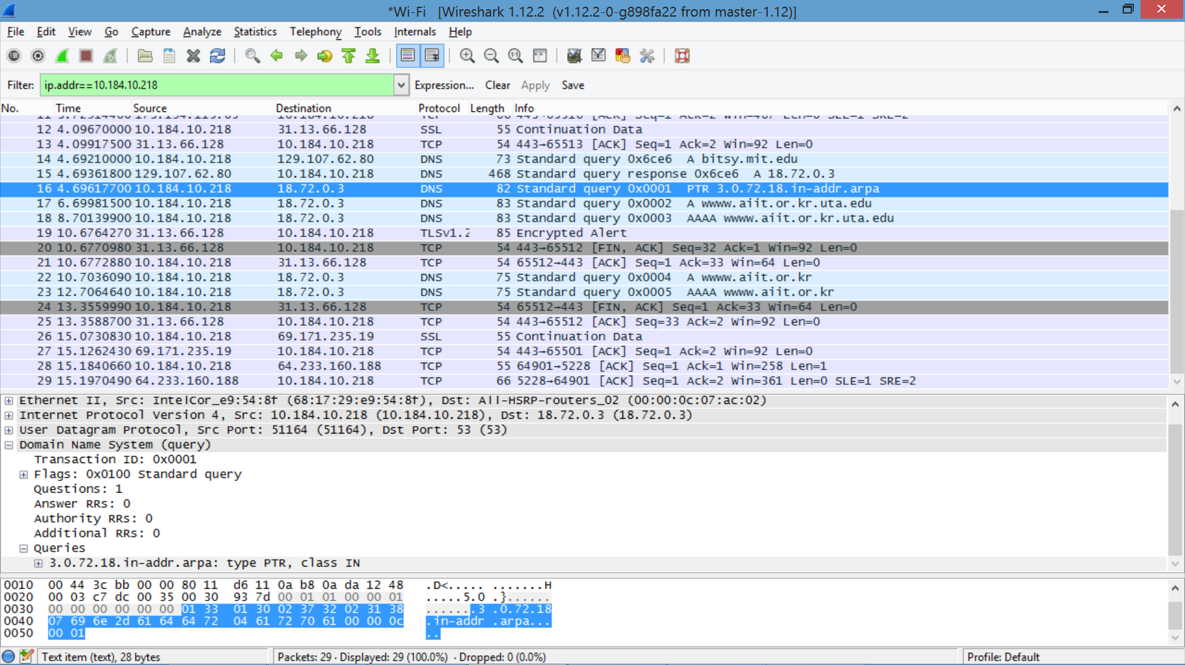

21. Examine the DNS query message. What “Type” of DNS query is it? Does the query message contain any “answers”?

-> The DNS query message is of PTR type and it does not contain any answers.



22. Examine the DNS response message. How many “answers” are provided? What does each of these answers contain?

|  |
| --- |
| Answers  bitsy.mit.edu: type A, class IN, addr 18.72.0.3  Name: bitsy.mit.edu  Type: A (Host Address) (1)  Class: IN (0x0001)  Time to live: 1371  Data length: 4  Address: 18.72.0.3 (18.72.0.3) |

23. Provide a screenshot.

